

**BUILDING LIFECYCLE REPORT**

Proposed Residential Development at Clonminch Road, Tullamore, Co. Offaly

August 2021

Van Dijk Architects

Morley Walsh Consulting Engineers DBFL Consulting Engineers

Stephen Ward Planning Consultants Park Hood Landscape Architects

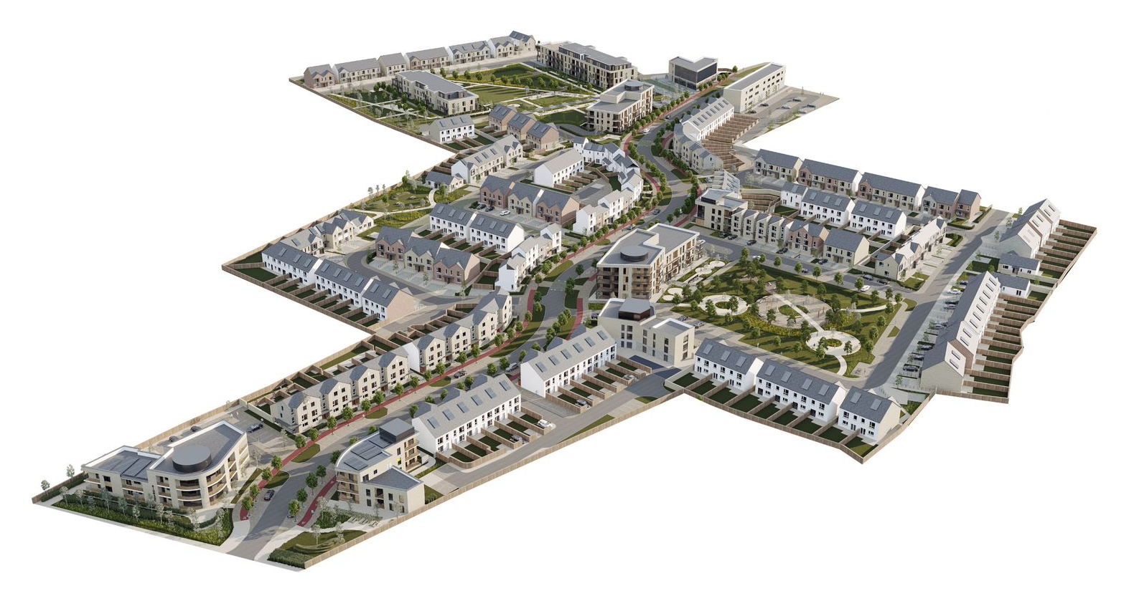

**INTRODUCTION**

The following report has been prepared in compliance with Section 6.13 of the 2018 Guidelines on design Standards for New Apartments as set out below:

*Accordingly, planning applications for apartment development shall include a building lifecycle report which in turn includes an assessment of long term running and maintenance costs as they would apply on a per residential unit basis at the time of application, as well as demonstrating what measures have been specifically considered by the proposer to effectively manage and reduce costs for the benefit of residents.*

Section 01 outlines the process to preparing the long term running and maintenance costs as they would apply on a per residential unit basis at the time of the application. Section 02 outlines the measures specifically considered by the proposer to effectively manage and reduce costs for the benefit of the residents.

**PROPOSED DEVELOPMENT**

The proposed development consists of Apartments, Duplex Units, Three Storeyed Houses, Two Storeyed Houses, Bungalows, a Creche, a local shop and neighbourhood centres including shops, medical centre, gym and business hub to services the development, landscaping, car parking, cycle storage facilities and associated site works.

2

**SECTION 01**

As required by the Multi-Unit Developments Act 2011, an owners management company must be set up, and the common areas of the development transferred to it, before the developer sells any unit. In addition the management company will mange the maintenance of the roads and open spaces until such time as those shown on the Taking in Charge map attached to the application have been taken in charge. The developer, may set up two management companies – one for the apartments (the main focus of this report) and one for the roads and open spaces.

An assessment of long term running and maintenance costs for the apartments is undertaken as they would apply on a per residential unit basis at the time of application.

**1.1**

**PROPERTY MANAGEMENT OF THE COMMON AREAS OF THE DEVELOPMENT**

A property management company will be engaged at an early stage of the development to ensure that all property management functions are dealt with for the development and that the running and maintenance costs of the common areas of the development are kept within the agreed annual operational budget.

The property management company will enter into a contract directly with the Owners Management Company (OMC) for the ongoing management of the built development. This contract will be for a maximum period of 3 years and in the form prescribed by the PSRA. The Property Management Company also has the following responsibilities for the apartment development once constructed:

•

Timely formation of an Owners Management Company (OMC) – which will be a company limited by guarantee having no share capital. All future purchasers will be obliged to become members of this OMC.

Preparation of annual service charge budget for the development common areas. Fair and equitable apportionment of the Annual operational charges in line with the Multi Units Development Act 2011 (MUD Act).

Engagement of independent legal representation on behalf of the OMC in keeping with the MUD Act - including completion of Developer OMC Agreement and transfer of common areas.

Transfer of documentation in line with Schedule 3 of the MUD Act. Estate Management.

Third Party Contractors Procurement and management. OMC Reporting.

Accounting & Corporate Services. Insurance Management.

After Hours Services & Staff Administration

•

•

•

•

•

•

•

•

•

•

4

**1.2**

**SERVICE CHARGE BUDGET**

The property management company has a number of key responsibilities, primarily the compiling of the service charge budget for the development for agreement with the OMC. The service charge budget covers items such as cleaning, landscaping, refuse management, utility bills, insurance, maintenance of mechanical/electrical lifts/ life safety systems, security, property management fee, etc., to the development common areas in accordance with the Multi Unit Developments Act 2011 (“MUD” Act).

This service charge budget also includes an allowance for a Sinking Fund and this allowance is determined following the review of the Building Investment Fund (BIF) report prepared for the OMC. The BIF report once adopted by the OMC, determines an adequate estimated annual cost provision requirement based on the needs of the development over a 30-year cycle period. The BIF report will identify those works which are necessary to maintain, repair, and enhance the premises over the 30year life cycle period, as required by the Multi Unit Development Act 2011. In line with the requirements of the MUD Act, the members of the OMC will determine and agree each year at a General Meeting of the members, the contribution to be made to the Sinking Fund, having regard to the BIF report produced. A sample format of the typical BIF report is set out in Appendix A.

Note: the detail associated with each element heading i.e. specification and estimate of the costs to maintain / repair or replace, can only be determined after detailed design and the procurement/ construction of the development and therefore the sinking fund requirements are listed to show what elements must be covered by this service charge.

5

183,603.06

382.50

556.92

364.14

7,070.13

3,636.81

807.84

2021 Service Charge Budget for Owners Management company

Apartments at Clonminch Road, Tullamore

Approved expenditure summary report of financial year of 1st of January to 31st December 2021

Cost category

All Apartments

Per Apartment

153

1. Management Costs 1.1Management costs
   1. Audit Fees
      1. Company Secretarial Services

€

€

€

27,540.00

2,385.27

446.76

€

€

€

180.00

15.59

2.92

1. Insurance
   1. Block Insurance
   2. Directors & Officers Liability

€

€

11,637.18

543.15

€

€

76.06

3.55

1. Services
   1. Internal Common Area Cleaning (once a week)
   2. Cleaning of Car-park & Bin bay area
   3. Window Cleaning (once per year)
   4. Landscaping (Apartments areas only)
   5. Balcony Glass Cleaning
   6. Refuse Collection
   7. Common Area Repairs and Maintenance

€

€

€

€

€

€

€

36,848.52

5,171.40

4,525.74

1,938.51

2,585.7

11,637.18

12,928.50

€

€

€

€

€

€

€

240.84

33.80

29.58

12.67

16.90

76.06

84.50

1. Health & Safety
   1. Fire Alarm Service (quaterly service)
   2. Emergency Lighting (quaterly service)
   3. Extinguisher Service (yearly service)

€

€

€

€

€

€

46.21

23.77

5.28

1. Lift Services
   1. Lift Maintenance
   2. Lift Repairs
   3. Lift Phone Rental

€

€

€

2,864.16

1,615.68

2,100.69

€

€

€

18.72

10.56

13.73

1. Electricity
   1. Public and Common Areal Electrical Costs

€

11,960.01

€

78.17

1. Other
   1. Bank Charges
   2. Postage, Stationary, etc
   3. Data Storage

€

€

€

€

€

€

2.50

3.64

2.38

1. Development Improvements - Long Term Plans
   1. Sinking Fund

€

34,056.27

€

222.59

GRAND TOTAL

€

€

1,200.00

**SECTION 02**

**2.1 ENERGY AND CARBON EMISSIONS**

The proposed development is subject to compliance with current Part L and also a residential policy (Chapter 8) of the Offaly County Council Development Plan (2014-2020) & Renewable Energy Directive 2009/28/EC and the National Renewable Energy Action Plan (NREAP) as the current Part L development is under review, the apartment dwellings have been designed to comply with the proposed Part L requirements which is a Near Zero Energy ( NZEB) standard.

NZEB requires “*that, the nearly zero or very low amount of energy required is covered to a very significant extent by energy from renewable sources including energy from renewable sources produced on-site or nearby”.*

The proposed development has been assessed by M&E consultants for compliance and is appended. ( Appendix B).

7

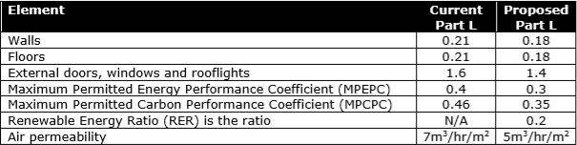

**2.2 MATERIALS- ENERGY EFFICIENCY**

As set out in building energy report, the proposed U-value for the primary element have been significantly improved on in the new proposed regulations as set out below.

The Fabric energy efficiency for the main elements of the project is set out as follows.

•

•

Walls Windows

factor of 0.7 or better)

Floors Doors

Air permeability Thermal Bridging

0.13 W/m2K

0.8W/m2K (solar fraction ( g factor) of 0.65, frame

•

•

•

•

0.13W/m2K

1.2 W/m2K 3m3/m2/hr Factor of 0.08

As evident from this, the materials proposed will be of a very high performance in terms of energy efficiency. This results in a reduction of running energy costs for the dwellings.

**2.3 ROBUST MATERIALS:**

The materials within the development have been chosen to find a balance between the outgoing costs for purchasers and ongoing maintenance. The life cycle of the materials is outlined in Appendix A ( Life expectancy/ BIF fund).

External Walls:

The following variety of materials has been chosen.

215mm High Density Concrete Blockwork Inner Leaf with 12mm Plaster Finish 150mm Cavity Fully Filled with High Density Rigid Insulation. Selected Brick or Render / External Window / Door Opes to have a 215mm deep Brick or Block Reveal

•

•

•

•

Zinc effect Aluminum Rainscreen Cladding.

Metal Cladding panel to Staircores in apartments.

Brick in select colours, grey and white as per the elevations. In sheltered areas, the use of timber effect (no maintenance) cladding is proposed. (Millboard or equal approved)

Windows:

Powder coated Aluminium or uPVC Double of Triple Glazed to achieve NZEB Building Regulation standards or better.

Toughened laminated glazing / Galvanised Steel balconies.

Gravel/Paving slabs on a Single Ply Roof Membrane with Separation Layer on 150-250mm Rigid Insulation on Vapor Control Membrane on 200 mm Concrete roof slab. No timber flat roofs to be employed anywhere within development.

Balconies:

Roof:

8

Concrete Tile Roof + Truss

Zinc effect aluminium / Metal Roofing Zinc effect aluminium / Metal Canopies

Boundary walls to houses and private areas will be concrete post and plank fencing, concrete block walling capped by concrete capping or brick walling capped by concrete capping throughout. No use of timber fences will be allowed anywhere within the development.

Canopies:

Boundaries:

Warrranties for all products within the project will be contained within the Health and Safety File and be retained by the Property management company on behalf of the OMC. A minimum of 25 years will be required for the primary elements.

Avoidance of Complex Details

Where possible architectural details have been kept as simple as possible. Complex details and junctions are more likely to lead to long term maintenance issues with movement over time causing potential for water ingress. Walls are straight and true without unnecessary stepping or complex brick detailing that might lead to poor weathering characteristics.

Balconies on top of living accommodation has been avoided or at least kept to a minimum throughout the development.

Finishes to public areas

The public sides of all buildings throughout the development are finished in different coloured brick finishes throughout. Painted render or self finished render is shown to private areas only. The use of self finished render with inherenet anti algacidal properties only will be allowed – Soltherm or similar.

**2.3 LANDSCAPE**

The aim of the Landscape Management is to provide a high standard for maintenance and management of landscape elements across the site to ensure successful establishment of proposed planting, visual integration of the development proposal into the surroundings and to protect and enhance nature conservation interests. This includes the appropriate maintenance of landscape components (parks, open spaces and boulevard which equate to well over 15% of the site) within an easily maintained comprehensive framework that can provide (where possible) a diversity of landscape experiences for the users, residents and visitors but does not rely on onerous management. The designs ensure high cost landscape management areas such as large shrub and herbaceous borders, small areas of mown grass or plants requiring high levels of maintenance are minimised.

The Landscape Management and Plan and associated maintenance schedules will be monitored and assessed for their effectiveness on an annual basis for the first five years following the completion of the development.

A Landscape Management & Maintenance Plan has been prepared by Landscape Architects Park Hood and is submitted under separate cover. The following design and management measures will be undertaken in relation to landscape maintenance:

1.

Robust high slip resistance materials to be used for paving, fencing, furniture, bin and bicycle storage units to minimise ongoing maintenance inputs.

9

2.

Pedestrian and cyclist friendly hierarchy of streets and open spaces are complemented by generous and high-quality landscape treatments providing long term high quality residential environments.

Sustainability aspects of the proposed development include the retention of trees and hedgerows where feasible and the use of native trees where possible across the site. Other species have been carefully selected for compatibility with the size of available spaces which is an important factor in long term management of the housing estate. The overall objective is to enhance the biodiversity potential of the site in addition to providing seasonal interest and variety.

Maintenance and management requirements have been considered through the design process. Complex planting arrangements have been omitted thus avoiding onerous maintenance and management requirements

3.

4.

**2.4 WASTE MANAGEMENT**

The following measures will be undertaken in relation to waste management in order to help reduce potential waste charges:

5.

An Operational Waste Management Plan has been prepared by AWL Consultants and forms part of the EIAR submitted under separate cover. This will be integrated into the Final Management Plan.

Competive tender for waste management collection, separation of Grey, brown and green waste.

Provision of organic waste bins to be provided.

6.

7.

10

**APPENDIX A- LIFE EXPECTANCY/ SINKING FUND CALCULATIONS**

The Owners’ Management Company shall also establish a building investment fund (referred to under the MUD Act as a ‘*sinking fund’*) for the purpose of discharging expenditure reasonably incurred on: -

•

•

•

•

Refurbishment Improvement

Maintenance of non-recurring nature

Advice from suitably qualified persons relating to refurbishment, improving and maintenance.

The owner of each unit in the multi-unit development shall be obliged to make payments to the sinking fund. The obligation to establish a sinking fund and to make contributions to such a fund shall apply on the passing of a period of 3 years since the first transfer of ownership. The contributions made towards the sinking fund shall be held in a separate account and in a manner which identifies these funds as belonging to the sinking fund (i.e. these funds shall not be used for refurbishment, improvement and non-reoccurring maintenance) Any such expenditure will need to be certified by the OMC Board and approved by a meeting of OMC members in accordance with the MUDS act.

11

BUILDING INVESTMENT FUND (Sinking Fund Per Annum Contribution)

Ref

Element

Life Expectancy

1

1.01

1.02

Roofs

Repair of flat roof covering.

Replacement of specialist fall arrest system

20

25

€

€

790.50

566.53

2

2.01

2.02

2.03

2.04

Elevations

Repair and clean down brick elevations / spray clean others Replace exist/ entrance doors

Replace rainwater goods Replace metal cladding

10

25

25

30

€

€

€

€

395.25

263.50

263.50

263.50

3

3.01

3.02

3.03

3.04

3.05

3.06

Stair core and lobbies Decorate ceilings and walls

Decorate joinery (stairwells & lobbies) Replace Firedoors (stairwells & lobbies) Replace floor finish (stairwells & lobbies) Replace entrance mats (stairwells & lobbies) Replace nosings (stairwells)

2

2

25

10

10

10

€

€

€

€

€

€

6,060.50

4,216.00

790.50

2,108.00

2,108.00

2,108.00

4

4.01

4.02

4.03

4.04

4.05

4.06

4.07

4.08

4.09

4.10

4.11

M&E services

General - Internal re-lamping (stairwells & lobbies) Replace Internal light fittings (stairwells & lobbies) Replace external light fittings (at entrance lobbies) Replace smoke detector heads

Replace manual break glass units/ disabled refuge call points Replace fire alarm panel

Replace lift car and controls Replace AOV's

Replace security access control installation Emergency lighting

Overhaul of waste pipes, stacks & vents

7

18

18

18

18

18

25

25

15

20

20

€

€

€

€

€

€

€

€

€

€

€

606.05

527.00

263.50

316.20

263.50

263.50

527.00

184.45

263.50

184.45

197.63

5

5.01

5.02

5.03

5.04

5.05

5.06

Contribution to Landscaping Sinking Fund Replace external signage

15-year cutback & thinning of trees and general overhaul of Replace cctv provision

External handrails and balustrade Repaint parking spaces and numbering Replace bicycle stands

18

15

10

18

5

25

€

€

€

€

€

€

210.80

1,054.00

263.50

210.80

790.50

289.85

€ 26,350.00

**APPENDIX B - ENERGY ASSESSMENT REPORT**

13



**Energy Statement for** Clonmich RoadDevelopment, Tullamore, Co. Offlay

Revision Ref: 2

08th 02nd 2021

**ENERGY STATEMENT**

**FOR**

**CLONMINCH ROAD DEVELOPMENT, TULLAMORE, Co. OFFALY**

Page 1 of 16

**Project:**

Clonminch Residential Development, Tullamore, Co. Offaly

**Client:**

STEINFORT INVESTMENTS FUND

**Architects:**

Van Dijk Architects, Mill House, Mill Street, Dundalk, Co.Louth

**Date Prepared:**

June 2020

**Revision Ref:**

2

**Date Of Issue:**

August 2021

**Prepared By:**

John Walsh, MSc, BSc, MIEI



**Energy Statement for** Clonmich RoadDevelopment, Tullamore, Co. Offlay

Revision Ref: 2

08th 02nd 2021

**Contents**

1.0 INTRODUCTION 3

2.0 PROPOSED DEVELOPMENT 3

3.0 BUILDING ENERGY RATING 3

4.0 UTILITIES 4

* 1. STRUCTURE AND BUILDING ELEMENTS 4
  2. Fabric ‘U’ Values Dwelling apartments 4
  3. Fabric ‘U’ Values Dwellings 4
  4. Fabric ‘U’ Values Commercial 5
  5. Air Permeability (Air Tightness against infiltration) 5
  6. Secondary Heat Source 5

6.0 UTILITIES 5

Figure 1: Existing Gas network near site (Blue) 5

Figure 2: Existing ESB network near/On site 6

Figure 3: Existing Virgin & Eircom network near/On site 6

7.0

ELECTRIC CAR CHARGEING POINTS 6

Figure 4: Current EV points in Tullamore 7

* 1. BUILDING SERVICES (M&E) OVERVIEW 7
  2. Heating & Ventilation systems apartments 7
  3. Heating & Ventilation Systems-Dwellings. 8
  4. Lighting 9

Figure 1: Existing Gas network near site (Blue) 5

Figure 2: Existing ESB network near/On site 6

Figure 3: Existing Virgin & Eircom network near/On site 6

Figure 4: Current EV points in Tullamore 7

Figure 5: Typical Exhaust Air Source HP arrangement 7

Figure 6: Typical Air Source HP arrangement for proposed dwellings 8

Figure 7: Typical Photovoltaic Arrangement 8

Figure 8: Roof Mounted Photovoltaics 9

Figure 9: Indicative layout of Roof Mounted Photovoltaics on Apartment Block 14

Figure 10: ESB Network Map in the Locality 15

Figure 11: GNI Map of Gas infrastructure in vicinity of Site 15

Figure 12: Eircom & Virgin infrastructure in vicinity of Site 16

Table 1: Summary of Part L compliance for apartment units 10

Table 2: Summary of Part L compliance for Dwellings 11

Table 3: Summary of Part L compliance for typical commercial unit 12

Page 2 of 16



;

**Energy Statement for** Clonmich RoadDevelopment, Tullamore, Co. Offlay

Revision Ref: 2

08th 02nd 2021

**1.0**

**INTRODUCTION**

This document provides an overview of the developments energy strategy report relates to the sustainability and energy targets proposed for the project and possible technologies that might be applied subject to further detailed design. The development must approach the energy design in an efficient manner that reduces energy demand initially through passive strategies such as an efficient envelope which in turn reduces the energy demands relating to items such as the heating system. This initial approach in reducing the energy demand significantly aids the project in obtaining the required energy goals. Performance criteria relating to the development’s envelope are set out in the following document.

The energy systems design must also focus on specifying energy efficient equipment to ensure the day to day running of the energy systems are optimized to further enhance energy savings and the related energy cost. Specifications relating to efficient heating, lighting and auxiliary equipment are set out in the document.

The report sets out to demonstrate a number of methodologies in Energy Efficiency, Conservation and Renewable Technologies that will be employed in part or in combination with each other for this development. These techniques will be employed to achieve compliance with the building regulations Part L and NZEB standards currently in public consultation.

**2.0**

**PROPOSED DEVELOPMENT**

The proposed works involve a residential development 358 dwelling and apartment residential units, with a mixture of commercial space, open space and play areas, associated internal roads, pedestrian paths, landscaping, lighting, car parking, connectivity works, infrastructure and site services.

**3.0**

**BUILDING ENERGY RATING**

As of 2006 all domestic buildings that were newly built and existing buildings that are for sale or rent require a BER (Building Energy Rating) certificate. The actual building energy rating is based on the primary energy used for one year and is classified on a scale of A1 to G with A1 being the most energy efficient. It also gives the anticipated carbon emissions for a year’s occupation based on the type of fuel that the systems use. In order to identify Primary energy consumption of the building, the BER assesses energy consumed under the following headings:

* Building type (house, apartment)
* Building orientation
* Thermal envelope (insulation levels of the façade, roofs, ground floor etc)
* Air Permeability (how much air infiltrates into the building through the façade)
* Heating systems (what type of heat source is used and how efficient)
* Ventilation (what form of ventilation is used. Natural vent, mixed mode mechanical ventilation)
* Fan and pump efficiency (how efficient are the pumps and fans)
* Domestic hot water generation (is a high efficiency boiler used)
* Lighting systems (how efficient is the lighting in the building

Through the specification of an energy efficient façade and HVAC systems, the energy consumption of the building will be reduced compared to a set baseline. This ensures the environmental and economic impact of the operation of the building is reduced. The key

Page 3 of 16



**Energy Statement for** Clonmich RoadDevelopment, Tullamore, Co. Offlay

Revision Ref: 2

08th 02nd 2021

philosophy of this plan is to reduce energy consumption by firstly limiting the energy needed by improving the buildings insulation. The second step is to utilize energy in the most efficient way through the selection and installation of energy efficient plant and equipment. The final step is to introduce energy from renewable sources to reduce the burden on Fossil Fuels.

**4.0**

**UTILITIES**

Initial discussions have taken place with the ESB regarding existing infrastructure in the locality. The preliminary loading for the site is estimated to be in the region of 500 kVA. (This is subject to change dependent on final renewable considerations etc. A number of sub stations will be required to ensure the electrical demand is met and these will be evenly distributed around the site. Overhead lines will be required to be downed and the MV network employed to feed these substations. The overhead 38kV lines will also be undergrounded and an indicative plan for same, subject to detailed discussions with the ESB has been included with this report. Also, included are existing infrastructure networks for Gas networks Ireland, Eircom and Virgin media.

**5.0**

**STRUCTURE AND BUILDING ELEMENTS**

While the construction works will incur an initial investment, the lifetime running cost of the building must be considered to reduce water, fuel and electrical energy consumption. To that end methods will be explored to further improve the building’s energy rating and reduce the carbon emissions. This includes decreasing the thermal conductivity (heat losses) of the building fabric, take advantage of passive solar gain to reduce the heating demand in the space and increase day lighting to reduce artificial lighting. Natural ventilation may be employed or if deemed as a requirement mechanical ventilation and heat recovery techniques will be employed to recover energy in the exhausted air. The following are some outline u-value specifications which will achieve the required energy specification:

5.1 Fabric ‘U’ Values Dwelling apartments

•

•

Walls Window

0.7 or better) Roof

Doors

Ground Floor slab Thermal Bridging

-

-

0.16-0.18 W/m2.K

1.2 W/m2.K (solar fraction (g factor) of 0.7, frame factor of

•

•

•

•

-

-

-

-

0.15W/m2.K (Flat roof)

1.4 W/m2.K (This is to include frame)

0.15 W/m2.K

Factor of 0.08, with junctions details to conform with

“Limiting Thermal Bridging and Air Infiltration – Acceptable Construction Details”

5.2

Fabric ‘U’ Values Dwellings

•

•

Walls Window

0.7 or better) Roof

Doors

Ground Floor slab Thermal Bridging

-

-

0.16-0.18 W/m2.K

1.2 W/m2.K (solar fraction (g factor) of 0.7, frame factor of

•

•

•

•

-

-

-

-

0.12 (Insulation, 200mm between Joist and 200mm over)

1.4 W/m2.K (This is to include frame)

0.15 W/m2.K

Factor of 0.08, with junctions details to conform with

“Limiting Thermal Bridging and Air Infiltration – Acceptable Construction Details”

•

Page 4 of 16



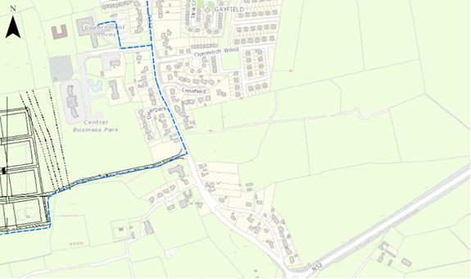

**Energy Statement for** Clonmich RoadDevelopment, Tullamore, Co. Offlay

Revision Ref: 2

08th 02nd 2021

5.3 Fabric ‘U’ Values Commercial

•

•

Walls Window

0.7 or better) Roof

Doors

Ground Floor slab Thermal Bridging

-

-

0.18 W/m2.K

1.2 W/m2.K (solar fraction (g factor) of 0.7, frame factor of

•

•

•

•

-

-

-

-

0.16

1.4 W/m2.K (This is to include frame)

0.16 W/m2.K

Factor of 0.08, with junctions details to conform with

“Limiting Thermal Bridging and Air Infiltration – Acceptable Construction Details”

5.4 Air Permeability (Air Tightness against infiltration)

One of the most significant heat loss factors in any buildings is through controlled and uncontrolled ventilation through the introduction of ambient/outside air into the heated space. The apartments are to be constructed with a high degree of air tightness to a possible value of 3m3/m2/hr or 0.15 Air Changes with a permeability test conducted post construction to demonstrate this level in accordance with the TGD’s.

5.5 Secondary Heat Source

The apartments and dwellings do not contain a secondary heat source therefore this is not applicable.

**6.0**

**UTILITIES**

The development is located adjacent to good network utilities, with a 4 bar natural gas main which can be extended into the site if required for cooking purposes and or for the commercial

units in the

Figure 1: Existing Gas network near site (Blue)

development to

work

in

conjunction with

the

renewable elements

proposed for

hating and hot water. Also. Gas may be utilized to work with

such technologies as combined heat

**Location of Site**

and

Power

(CHP) and Gas

fired pumps.

heat

The ESB has also forwarded details of the network in their vicinity and a number of overhead MV lines will be required to be grounded as the development progresses. Also, there is a MV network served

Page 5 of 16



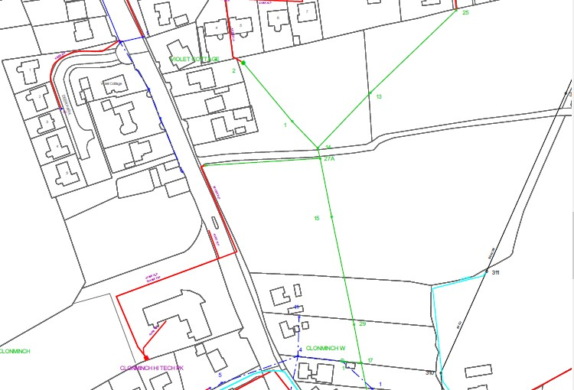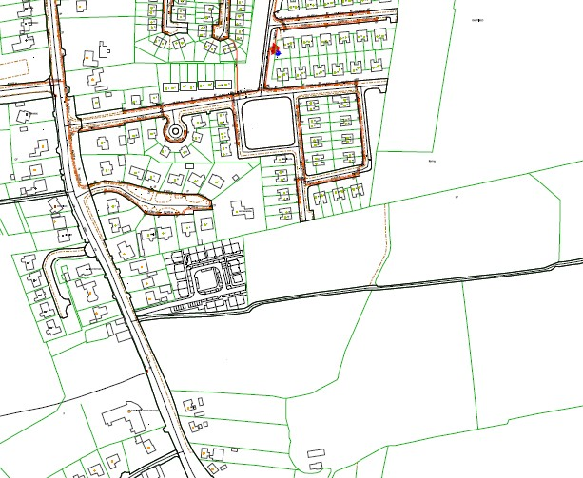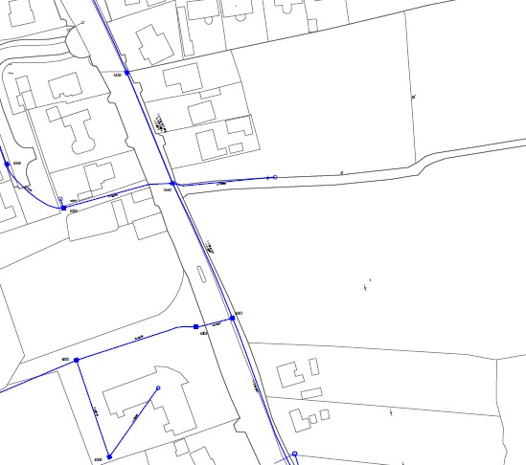

**Energy Statement for** Clonmich RoadDevelopment, Tullamore, Co. Offlay

Revision Ref: 2

08th 02nd 2021

underground at the site entrance served from a substation at “CLONMINCH HI TECH PK” opposite the site. Similarly, there is a good communications network in the area with both Virgin, Siro and Eircom with communication networks in the vicinity. Virgin have indicated in writing to us that they are currently planning to bring Fibre to the Home (FTTH) to a smaller development of 18 units adjacent to this one in Clonminch with the intention to extend FTTH to this development.

Figure 2: Existing ESB network near/On site

ESB Legend:

**Location of Site**

Figure 3: Existing Virgin & Eircom network near/On site

**Eircom Layout & Location of Site**

**7.0**

**ELECTRIC CAR CHARGEING POINTS**

There are presently only 3 electric car charging points in the town of Tullamore, Market Square, Tanyard Lane and adjacent to Tullamore Court Office. In line with government policy and share

Page 6 of 16

**Virgin Layout & Location of Site**

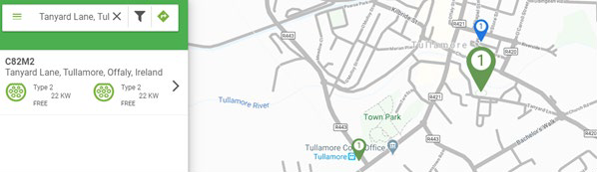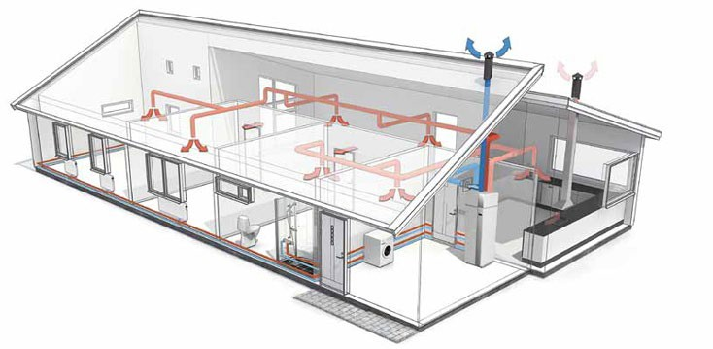

**Energy Statement for** Clonmich RoadDevelopment, Tullamore, Co. Offlay

Revision Ref: 2

08th 02nd 2021

of projection of annual sales grows to 42% by 2020, enabling Ireland to meet the 10%i EV penetration target, and to 60% by 2050, resulting in 1.8m EVs in a total car stock of 2.9m vehicles, the development incudes for a minimum of 10% capacity of carparking spaces in both the public realm and on individuals dwellings for the development.

Figure 4: Current EV points in Tullamore.

**8.0 BUILDING SERVICES (M&E) OVERVIEW**

8.1 Heating & Ventilation systems apartments

It is proposed to consider various options for heating of apartments and dwelling to include possible heat pumps or exhaust air heat pumps.

Figure 5: Typical Exhaust Air Source HP arrangement

Page 7 of 16

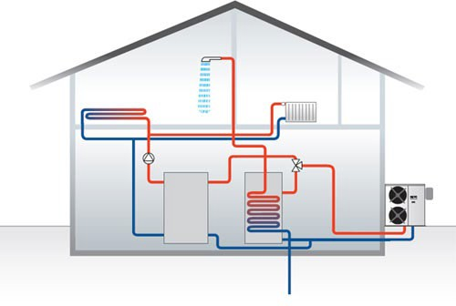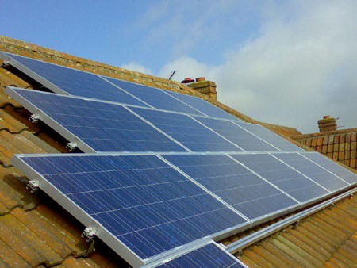

**Energy Statement for** Clonmich RoadDevelopment, Tullamore, Co. Offlay

Revision Ref: 2

08th 02nd 2021

Air source heat pumps utilize low grade heat from external ambient air and transfer heat to heating system pipework. These systems operate with very high efficiencies (>400%) which provides significant carbon reductions in comparison to a traditional boiler system.

Exhaust air heat pumps utilize an exhaust air heat pump type system for heating, hot water and ventilation of the apartment units. This will re-cycle the heat from your house’s ventilation system. These machines are ideal for apartments and more compact air-tight low energy or passive homes. Air is drawn through ducts to the heatpump from the bathrooms, utility and kitchen areas. The cold waste air is discharged to outside through another duct, and condensation to a drain.

Additional

heat

generated

internally

from

lighting,

people & domestic appliances is also utilized through heat recovery.

For every unit of electricity used to operate the heat pump, up to four to five units of heat are generated. Therefore for every unit of electricity used to generate heat, 4-5 (400-500%) units of heat are produced. Efficiencies in order of 600% may also be achieved depending on ambient conditions. It is proposed to utilise radiator heating in the apartment units as heating emitter. These can be employed with gas boilers or heat pumps which utilise the low heating temperature from the heat pump. A central time clock and separate time and temperature controls to each zone is to provided (e.g. via 2-port valves). Such zones may consist of:

* living areas,
* Bedrooms
* Domestic Hot water

8.2 Heating & Ventilation Systems-Dwellings.

It is proposed to consider various options for heating and hot water of the dwellings, particularly Air to Water heat pumps (AWHP). This can be either mono-block where the heating is plumbed externally from the condenser to the dwelling or split where the refrigerant pipework passes between the condenser and evaporator in the dwelling. Air source heat pumps utilize low grade heat from external ambient air and transfer heat to heating system pipework. These systems operate with very high efficiencies (>400%) which provides significant carbon reductions in comparison to a traditional boiler system.

Figure 6: Typical Air Source HP arrangement for proposed dwellings

Figure 7: Typical Photovoltaic Arrangement

Page 8 of 16

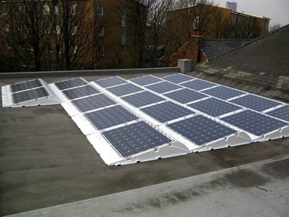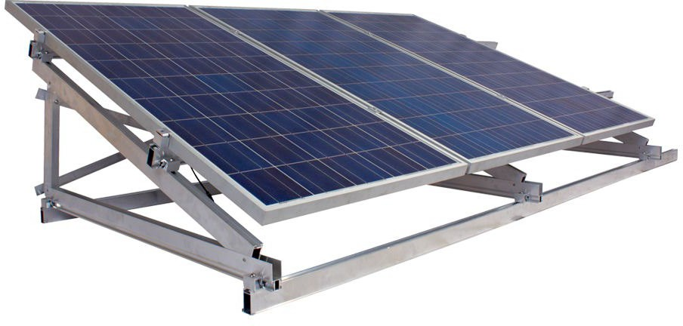

**Energy Statement for** Clonmich RoadDevelopment, Tullamore, Co. Offlay

Revision Ref: 2

08th 02nd 2021

Photovoltaic panels are best suited to sites which have an unobstructed southerly and south- easterly elevations. PV is particularly suitable due where there is a simultaneous requirement for heating, hot water and electrical demand. these may be considered by the developer The on- site generation of electricity can supplement the electrical requirement for lighting, motors, etc & reduce the electrical demand and from the grid.

Utilising this technology would considerably reduce the demand from the grid and consequently reduce losses and emissions from power stations. Such is the benefit of on site or distributed generation, the DEAP model determines that each kWh offset from PV equates to circa 2.5 times the thermal equivalent and reduces CO2 emissions by some 0.47Kg/kWh generated.

Figure 8: Roof Mounted Photovoltaics

8.3 Lighting

All lighting to be energy efficient with provision made for low energy lamps such as Compact Fluorescent Lamps (CFLs) or LED lamps which use 80% less electricity and last up to 10 times longer than ordinary light-bulbs.

Page 9 of 16



**Energy Statement for** Clonmich RoadDevelopment, Tullamore, Co. Offlay

Revision Ref: 2

08th 02nd 2021

Table 1: Summary of Part L compliance for apartment units

Page 10 of 16

**Typical Ground/top floor Typical Mid floor apartment apartment**

**U-values**

[w/m2.k]

[w/m2.k]

**Floor [Max, Part L 2011 = 0.21]**

0.15

N/A

*Floor to have minimum 100MM PIR with thermal conductivity of*

*0.022 w/m2.k*

**Roof [Max, Part L 2011 =**

**0.16 Insulation on Ceiling/rafter]**

0.15

N/A

*Flat ceiling insulation to be minimum 140mm Moy with thermal conductivity 0.024 wm2.k*

**Wall [Max, Part L 2011 = 0.21]**

0.18

0.18

Wall insulation to comprise 100mm PIR board with thermal conductivity 0.023 w/m2.k

**Door [Max, Part L 2011 = 3.0]**

1.4

1.4

**Window [Max Av, Part L 2011 = 1.6], solar factor**

**0.73**

1.2

1.2

*Windows to south façade to have minimum solar factor of 0.5*

**Mechanical plant**

**Heating source**

Exhaust air source heat pump.

Exhaust air source heat pump.

**Heating controls**

Time and temperature control of heating/hot water with individual heating zones

Time and temperature control of heating/hot water with individual heating zones

**Heat emitters**

Oversized radiators with mean water temperature 40 Deg C

Oversized radiators with mean water temperature 40 Deg C

**Solar requirements**

Up to 2 No. 340w PV panel per unit if required dependent on orientation and heating system utilised.

Up to 2 No. 340w PV panel per unit if required dependent on orientation and heating system utilised.

**Hot water cylinder**

180 litre cylinder

180 litre cylinder



**Energy Statement for** Clonmich RoadDevelopment, Tullamore, Co. Offlay

Revision Ref: 2

08th 02nd 2021

Table 2: Summary of Part L compliance for Dwellings

Page 11 of 16

**Door [Max, Part L 2011 = 3.0]**

1.4

**U-values**

[w/m2.k]

**Floor [Max, Part L 2011 = 0.21]**

0.1

*Floor to have minimum 100mm PIR with thermal conductivity of*

*0.022 w/m2.k*

**Roof [Max, Part L 2011 = 0.16 Insulation on Ceiling/rafter]**

0.12

*400mm Insulation, 200mm between Joists and 200mm Over ceiling insulation to be minimum thermal conductivity 0.04 wm2.k*

**Wall [Max, Part L 2011 = 0.21]**

0.18

Wall insulation to comprise 125mm PIR board with thermal conductivity 0.022 w/m2.k

**Ventilation**

Centralised ducted extract system serving heat pump. Specific fan power 0.33 w/l/s minimum or Natural Ventilation.

Centralised ducted extract system serving heat pump. Specific fan power 0.33 w/l/s minimum or Natural Ventilation.

**Additional requirements**

**Lighting**

100% energy efficient lighting

100% energy efficient lighting

**Air permeability**

Air permeability @ 3 m3/hr/m2

Air permeability @ 3 m3/hr/m2

**Thermal bridging**

Factor of 0.08, junctions details to conform with “Limiting Thermal Bridging and Air Infiltration – Acceptable Construction Details”

Factor of 0.08, junctions details to conform with “Limiting Thermal Bridging and Air Infiltration – Acceptable Construction Details”

**Secondary heating**

N/A

N/A

**BER results**

49 (A2)

44 (A2)

**EPC [MPEPC = 0.4]**

0.293

0.275

**CPC [MPCPC = 0.46]**

0.276

0.26

**Renewable contribution [kwhrs]**

17.5

22



**Energy Statement for** Clonmich RoadDevelopment, Tullamore, Co. Offlay

Revision Ref: 2

08th 02nd 2021

Table 3: Summary of Part L compliance for typical commercial unit

Page 12 of 16

**Window [Max Av, Part L 2019**

**= 1.6], solar factor 0.73**

1.2

*Windows to have minimum solar factor 0.7*

**Mechanical plant**

**U-values**

[w/m2.k]

**Floor [Max, Part L 2019 = 0.18]**

0.18

*Floor to have minimum 100-125MM PIR with thermal conductivity of 0.022 w/m2.k*

**Roof [Max, Part L 2019 = 0.2 Insulation on Ceiling/rafter]**

0.16

**Wall [Max, Part L 2019 = 0.18]**

0.18

Wall insulation to comprise 100mm PIR board with thermal conductivity 0.023 w/m2.k

**Door [Max, Part L 2019 = 3.0]**

1.4

**Window [Max Av, Part L 2011**

**= 1.6], solar factor 0.73**

1.2

*Windows to have minimum solar factor of 0.7*

**Mechanical plant**

**Heating source**

Air to Water air heat pump or Gas Boiler.

**Heating controls**

Time and temperature control of heating/hot water with individual heating zones

**Heat emitters**

Oversized radiators with mean water temperature 40 Deg C

**Solar requirements**

Up to 6-8 No. 330w PV panel per unit if required dependent on orientation and heating system utilised.

**Hot water cylinder**

180 litre cylinder

**Ventilation**

Centralised ducted extract system serving heat pump.

Specific fan power 0.33 w/l/s minimum

**Additional requirements**

**Lighting**

100% energy efficient lighting

**Air permeability**

Air permeability @ 3 m3/hr/m2

**Thermal bridging**

Factor of 0.08, junctions details to conform with “Limiting Thermal Bridging and Air Infiltration – Acceptable Construction Details”

**Secondary heating**

N/A



**Energy Statement for** Clonmich RoadDevelopment, Tullamore, Co. Offlay

Revision Ref: 2

08th 02nd 2021

Page 13 of 16

**Heating/cooling source**

Air conditioning split heat pump unit SSEER <2

**Heating controls**

Time and temperature control of heating/hot water with individual heating zones

**Heat emitters**

Heat/cooling via ventilation grilles

**Solar requirements**

340w PV panel per unit if required dependent on orientation and final design of heating system utilised.

**Hot water**

Via heat pump

**Ventilation**

Ventilation provided via ducted air supply from external. Extract from wet areas in accordance with CIBSE requirements. Specific fan power 1.2 w/l/s minimum

**Additional requirements**

**Lighting**

Lighting to have minimum 80 lumens/watt with lighting controls to incorporate daylight/occupancy sensing

**Air permeability**

Air permeability @ 3 m3/hr/m2

**Thermal bridging**

Factor of 0.08, junctions details to conform with “Limiting Thermal Bridging and Air Infiltration – Acceptable Construction Details”

**BER results**

(A3)

**EPC [MPEPC = 1]**

<1

**CPC [MPCPC = 1.15]**

<1.15

**Renewable contribution**

20% Minimum

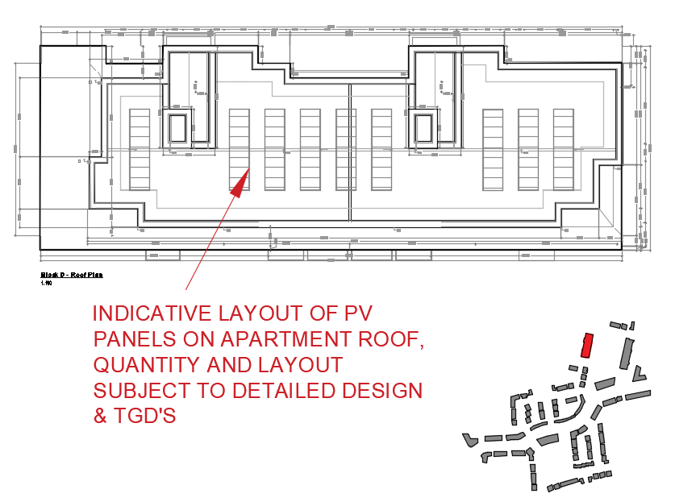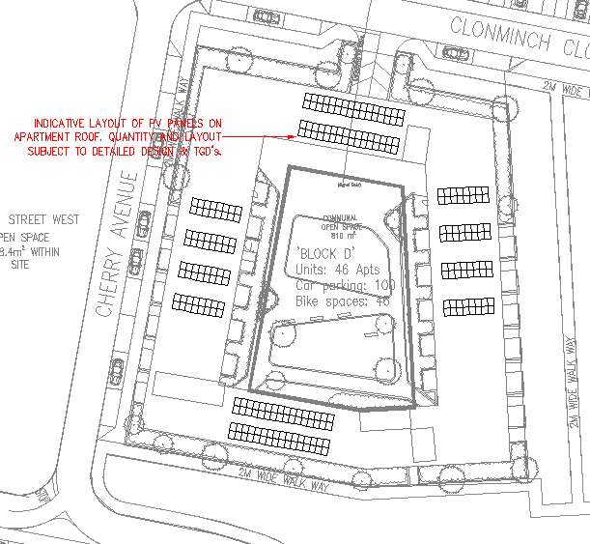

**Energy Statement for** Clonmich RoadDevelopment, Tullamore, Co. Offlay

Revision Ref: 2

08th 02nd 2021

Figure 9: Indicative layout of Roof Mounted Photovoltaics on Apartment Block.

Page 14 of 16

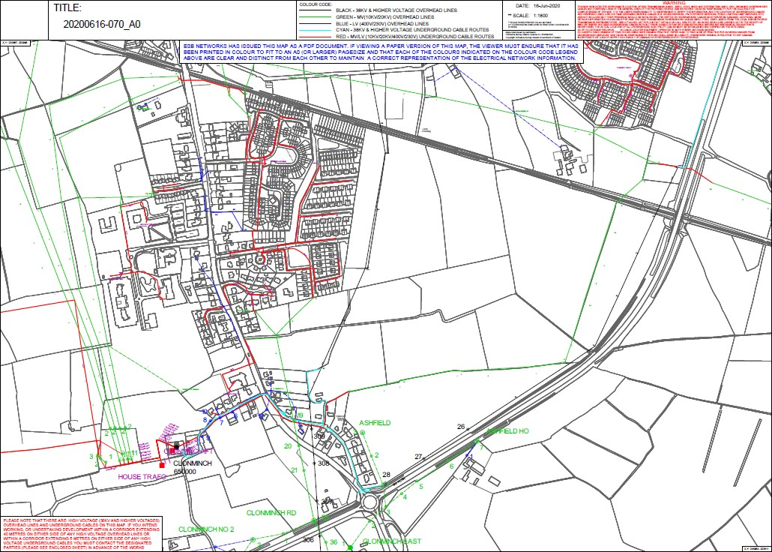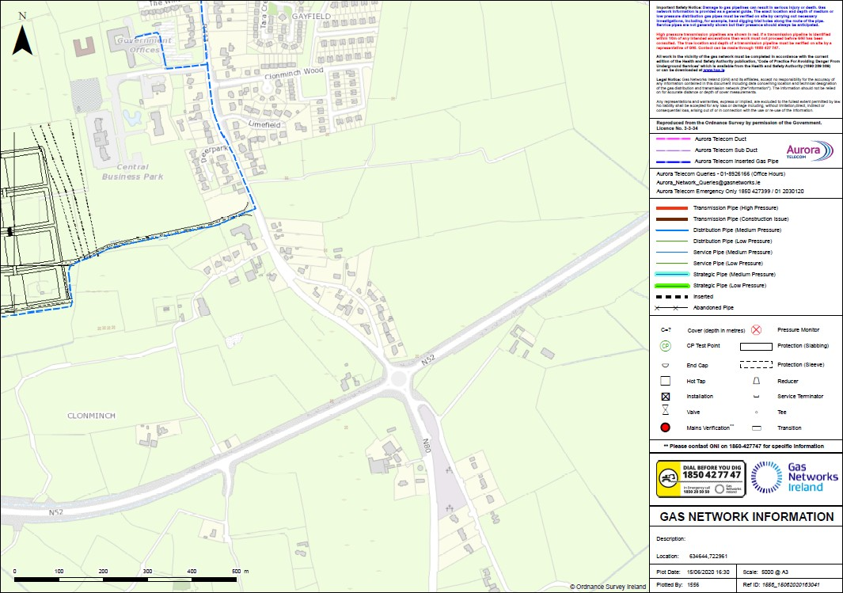

**Energy Statement for** Clonmich RoadDevelopment, Tullamore, Co. Offlay

Revision Ref: 2

08th 02nd 2021

Figure 10: ESB Network Map in the Locality

Figure 11: GNI Map of Gas infrastructure in vicinity of Site

Page 15 of 16

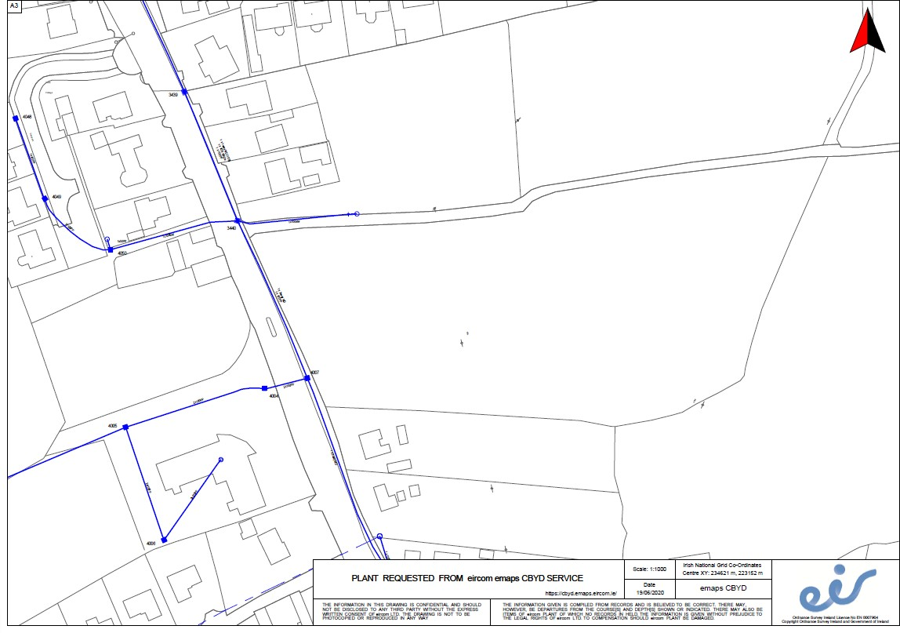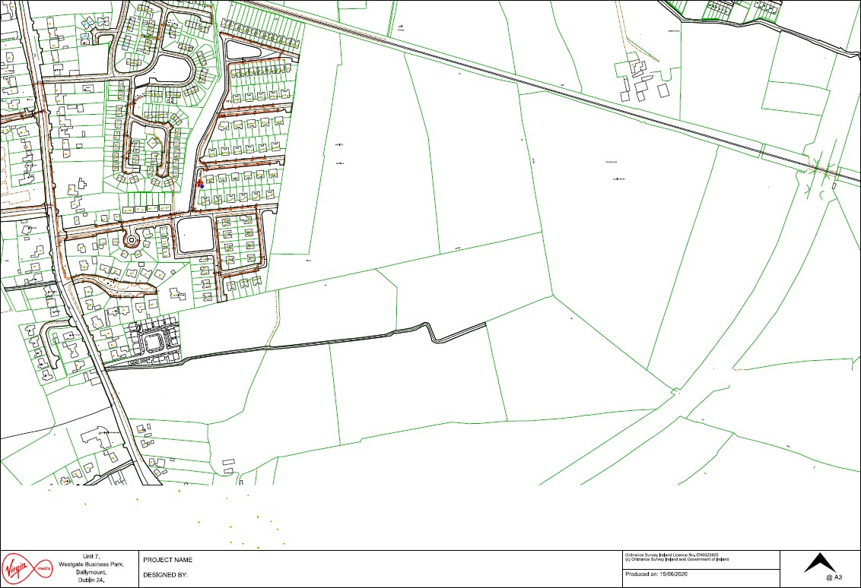

**Energy Statement for** Clonmich RoadDevelopment, Tullamore, Co. Offlay

Revision Ref: 2

08th 02nd 2021

Figure 12: Eircom & Virgin infrastructure in vicinity of Site

Page 16 of 16